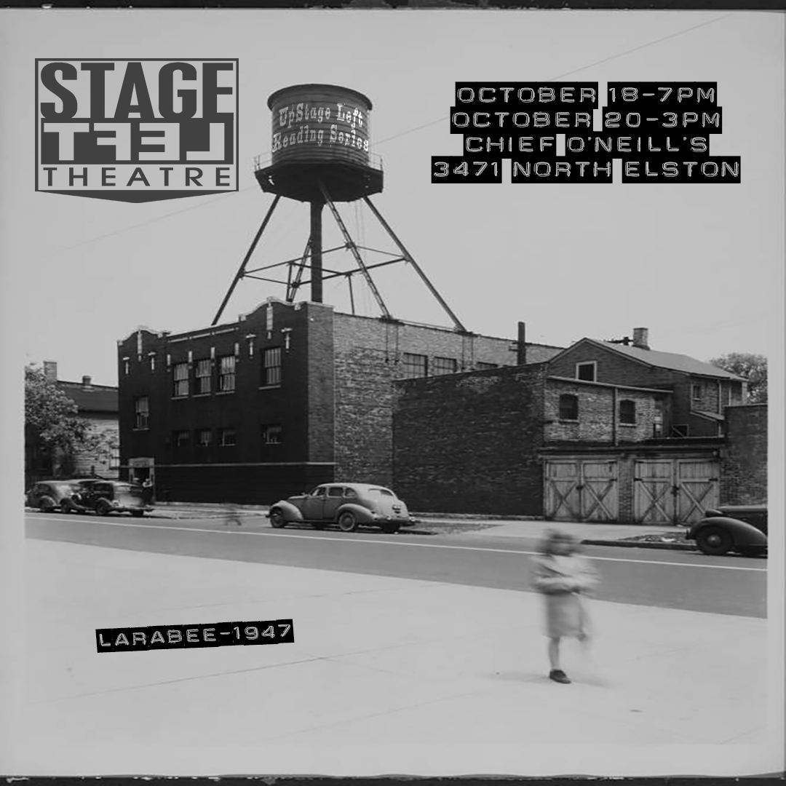

Friday, October 18, 7:00pm  Sunday, October 20 at 3:00pm  at Chief O'Neill's restaurant: 3471 N. Elston Ave. | 
Bulldozers  by Greg Romero  Directed by Doug Long  Starring  Kirsten D’Aurelio as Barbara Whitehead  Camelia Patron as Elise  Jeanne Williams as Community Member  Christopher Williams as Community Member  Brittany Mayti as Community Member | The Oceanarium  by Kevin Michael Wesson  Directed by Iris Sowlat  Starring  Tera Flores as Dakota  North Rory Homewood as Jamie  Peyton Gray Robbins as Rain  Kit Kelsey as Harp
I Killed Andy Breitbart
by Pam Dickler
Directed by Drew Martin

Starring Pam Dickler

(UP)Stage Left Reading Series is brought to you by
Stage Left Theatre, Rachel Van Warnick, Artistic Director. Stagelefttheatre.com

