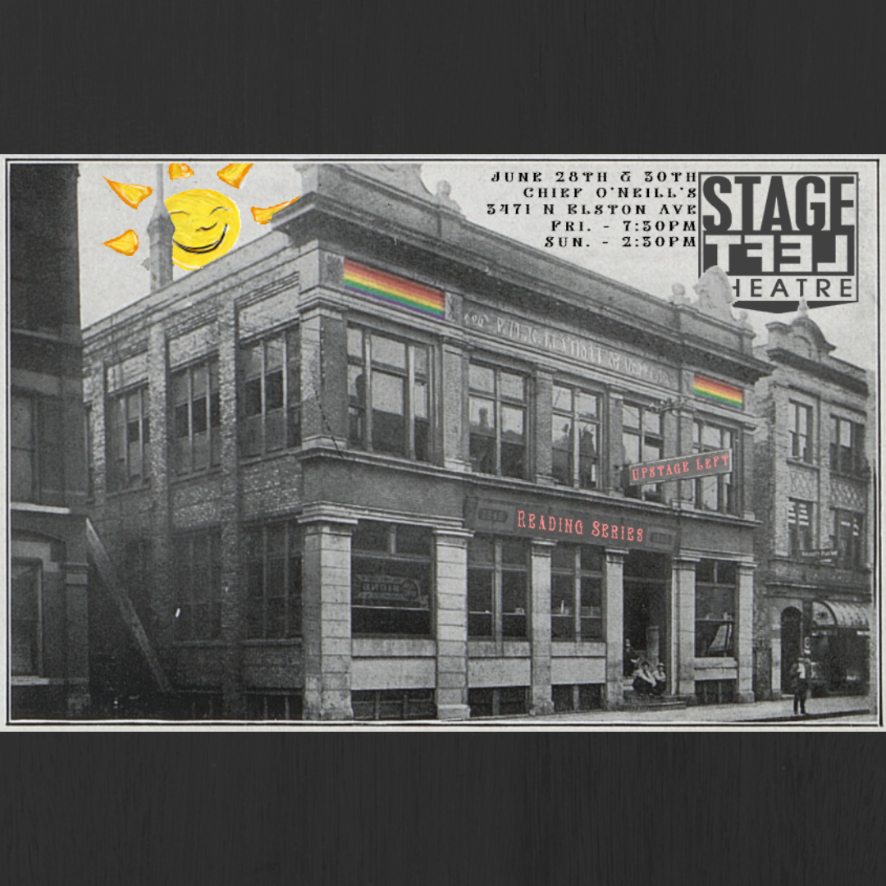

Stage Left Theatre Presents:
(Up)Stage Left Reading Series

Friday, June 28th - 7:30p
Sunday, June 30th - 2:30p

*denotes ensemble member of Stage Left

Big Iron Fires by Greg Romero, with music composed by Mike Vernusky
Directed by Kyle Aschbrenner*

Nina……………………………..Hannah Goodman
Gwen……………………………Siubhan Stormont
Treplev………………………….Christian Boswell
Volunteer……………………….Morgan Braithwaite

Content Warning: Gun shot sound effects

Sprinkles by Stephanie Murphy*
Directed by Seth Valentine*

Pete……………………………Kenneth Martin*
Ryan…………………………...Peter Leondedis*

The Various Musings of Mass Hysteria by Hannah Kfoury
Directed by Noah Watkins

Rory…………………………..Erik Hylko
Nathan……………………….Graham Heacock
Chloe…………………………Samantha Nieves
Olivia…………………………Becca Schwartz

Stage Directions read by Artistic Director, Rachel Van Warnick*

